First Research Idea

First step: presence of resting spores
IF IT WORKS
Second step: Quantity of of resting spores

NEXT: presence of the virus, RNA
Fourth step: quantity of the virus

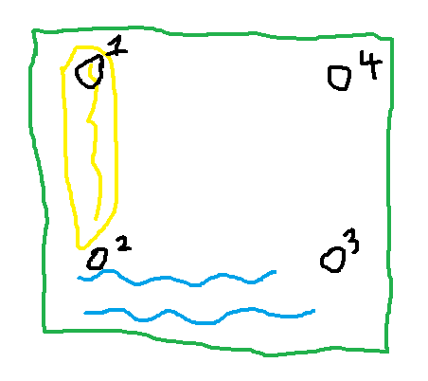
Field with sample locations

Research question: How does the quantity of Polymyxa graminis resting spores vary in different depths and characteristics of soil? How do these correlations affect the infectious potential of the soil?

Methods
- Go to field (the one discussed during yesterday’s meeting)
- Get 2 repetitions, 3 depths (0-20, 20-40, 40-60 cm) from 4 spots at the field, 24 soil samples + 8 undeformed samples
- Test for presence of spores in soil, options of methods:
  - ExgeneTM Plant SV mini kit (GeneAll, Seoul, Korea) and UltraClean Soil DNA Isolation Kit (MO BIO Laboratories, Inc., Carlsbad, CA)
  - “Classical Pg detection” (Arvalis article), sequencing by Sanger technology
  - PCR and Quantitative RT-PCR
- Send for characterization of soil sample at the same time (texture, pH, water content, bulk density, organic matter content)
- If the test for the presence of spores works, quantify the fungus. How much there is per soil sample.
- Next step, test for presence of the virus.
- If time, quantify the amount of virus.
- Once soil characteristics come back, you can look for connections between these.

Materials for in field

Soil auger, soil ring sampler (100cc?), 2 hammers, knife, sampling bags,

Plan of Work

1. Sampling:
Field visit,
2 replicates, 3 depths (0-20, 20-40, 40-60 cm) from 4 spots at the field, 24 soil samples + 8 undeformed samples

2. Test for presence of spores by Extraction and Counting of Resting Spores of P. graminis by following procedure from (Tyagi, S. et al, 2016):
The powder of soil (1 g) potentially containing P. graminis are soaked in 5 ml of 1 % sodium meta hexa phosphate buffer containing Tween 20 (0.25 %) and phenyl acetic acid (final concentration 50 lg/ll) [30–32]. Then, the suspension is homogenized using Tissuelyser LT (Qiagen, Hilden, Germany) and subjected to centrifugation at 16,000 rpm for 5 min. Supernatant is filtered through eight layers of Miracloth (Calbiochem, San Diego, CA), followed by centrifugation at 3000 rpm for 5 min. Then, the filtrates are mixed (1:1 = v/v) with 200 lg/ml of Fluorescent Brightener-28 (Sigma, Saint Louis, MO) to visually distinguish resting spores. The number of resting spores emitting 405 nm of fluorescence is counted on haemacytometer (Neubauer-improved, Lauda-Ko ̈ nigshofen, Germany) under fluorescent microscope. (Tyagi, S. 2016)
3. Characterization of soil samples for various parameters including:
- Texture
- pH
- Water content
- Bulk density
- Organic matter content
4. Molecular identification of P. graminis
PCR:
UltraClean Soil DNA Isolation Kit (MO BIO Laboratories, Inc., Carlsbad, CA), following the manufacturers’ instructions. A pair of primers-Pgfwd2 (50-GGA AGG ATC ATT AGC GTT GAA T-30 ) and Pxrev7 (50 -GAG GCA TGC TTC CGA GGG CTC T-30) - is used to amplify a 270 bp fragment of the nuclear ribosomal DNA of P. graminis. The standard PCR protocols used for the detection of P. graminis would be adapted from Ward and Adams. The PCR reaction was performed in a 50 ll reaction volume containing 100 ng DNA, 5 ll ExTaq reaction buffer, 4 ll dNTPs (0.25 mM), 0.5 ll Pxrev7 primer (10 pM), 0.5 ll Pgfwd2 primer (10 pM), and 1U ExTaq polymerase (TaKaRa ExTaqÒ DNA Polymerase, China). Amplification was performed using a GeneAmp 9700 PCR thermocycler (Applied Biosystems, CA, USA) using program as 95 °C for5min,35cyclesof95°Cfor30s,53°Cfor30sand 72 °C for 30 s and final synthesis for 7 min at 72 °C. roots free from P. graminis were used as a negative control. The amplified products were visualized by ethid- ium bromide staining on 1.0 % of agarose gel.
Quantitative Real-Time PCR
In the case of the quantitative real-time PCR, total DNA is extracted from resting spore suspension using Exge- neTM Plant SV mini kit (GeneAll, Seoul, Korea). PCR reaction is performed in Rotor-GeneTM 6200 real-time thermal cycler (Corbett Research, Mortlake, NSW, Aus- tralia). The PCR mixture (20 ll) is prepared with 10 ll of SYBR Green Master mixture (Applied biosystems, San Diego, CA), 0.5 ll of reverse and forward primer (10 pM), and 100 ng of template DNA. The amplification reaction is conducted based on thermo cycles (three step melt) as follow: with 40 cycles, each composed of (1) 95 °C for 10 s,(2)55 °C for30 sand(3)extensionat72 °Cfor30 s. The reaction mixture without DNA template was used as negative control.

Protocol: Tyagi, S., Sultana, R., Ju, H., Lee, W. J., Kim, K., Lee, B., & Lee, K. (2016). The Development of Simple Methods for the Maintenance and Quantification of Polymyxa graminis. Indian Journal of Microbiology, 56(4), 482–490. https://doi.org/10.1007/s12088-016-0608-2

test

